Facebook and Voting Information

Your group will have 15 minutes for this activity. One group member should volunteer to copy this document, share the copy with their group (so that anyone can edit), and read Proposal 1 and Proposal 2 out loud to the group. (In the absence of a volunteer, nominate whoever's last name is alphabetically first!) The group should collectively then answer the questions below, replacing each TODO with the group's collective thoughts.

# Proposals

## Proposal 1

Facebook has updated their user interface so that a "Voting Information Center" post is pinned to the top of users' news feeds. The post contains "Facts About the Election" that are sourced from the Bipartisan Policy Center.

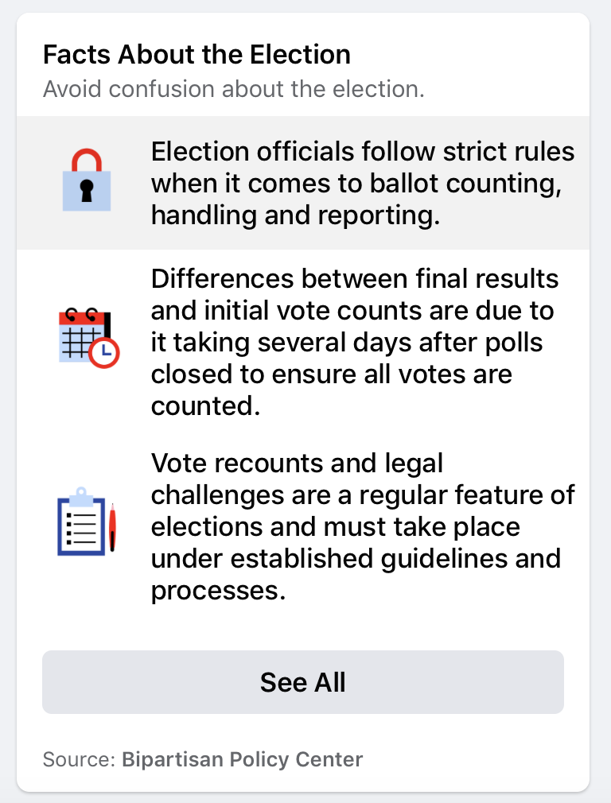

## Proposal 2

However, a designer at Facebook believes that there needs to be a different approach to content regulation. Their proposal is that the "Facts About the Election" should be replaced with partisan views on this topic displayed side-by-side, while remaining pinned at the top of everyone’s news feed. For example, the partisan display should include Republicans' claims that there has been rampant voter fraud and that states have been including illegal ballots in their vote counts, as well as Democrats' claims that there is no evidence of voter fraud nor states acting illegitimately in the vote counting process.

# 

## **Five Rights and Opportunities for a Democratic Public Sphere**

# **Rights**. As citizens of a democracy, we have rights to basic liberties, such as liberties of expression and association. The right to expressive liberty is important not only for the freedom of the individual, so that he or she is not censored, but also for democracy itself. It enables citizens to bring their ideas into conversation with one another, and to criticize and hold accountable those who exercise power.

# **The opportunity for Expression**. Not only should we be free of censorship but we should have fair opportunity to participate in public discussion. It shouldn't be the case that because someone is wealthier or more powerful that they should have more opportunity to participate.

# **Access**. Each person should have good and equal access to quality and reliable information on public matters. That is, IF we make the effort, we should be able to acquire this information. Effective participation in decision making on public matters requires being informed.

# **Diversity**. Each person should have good and equal chances to hear a wide range of views. We need access to competing views in order to have a more informed and reasoned position.

# **Communicative power**. Citizens should have good and equal chances to explore interests and ideas in association with others, and through these associations, to develop new concerns that challenge the mainstream view.

# 

# Questions

1. Which form of content regulation, Proposal 1 or Proposal 2, do you feel is better? Why?
   1. We thought Proposal 1 was better, because it is taking a distance and staying neutral with regard to all the tension going on between both parties; it would ensure that Facebook users are provided with verified information only not claims made by each party. Additionally, the second proposal would hinder diversity of opinions since each user is most likely to only read their party’s claims.
2. Which form of content regulation, Proposal 1 or Proposal 2, do you think best preserves or promotes the [five rights and opportunities necessary for a democratic public sphere](https://cs50.harvard.edu/college/2020/fall/labs/10/lecture/#five-rights-and-opportunities-for-a-democratic-public-sphere)?
   1. Which proposal best preserves or promotes Rights? Why?
      1. Proposal 1 and 2 both equally promote rights as everyone is receiving the same rights on Facebook. (/Proposal 2 could be interpreted as limiting freedom of thought)
   2. Which proposal best preserves or promotes Opportunity for Expression? Why?
      1. Proposal 2 provides more space for expression.
   3. Which proposal best preserves or promotes Access? Why?
      1. Proposal 1 promotes access because the information from the Bipartisan Policy Center are likely to be more reliable than some of the other sources on either side.
   4. Which proposal best preserves or promotes Diversity? Why?
      1. Proposal 2 best promotes Diversity because it offers both conflicting viewpoints as opposed to attempting to take a neutral stance. Assuming users read both stances, this offers a greater variety of opinion.
   5. Which proposal best preserves or promotes Communicative Power? Why?
      1. Proposal 2 better promotes communicative power. Partisan information would give users the opportunity to aggregate with others on the platform that hold similar views.